**BUDDHA SENSOR**

To: Jason Loeb

125 Atlantic Street

Quincy, MA 02171

From: Elisha Tam

20800 Boyce Lane

Saratoga, CA 95070

**Shipped Supplies**

1. 1 Sir Speedy box, containing Arduino, white breadboard, & relay
2. 1 USB 2.0 A - B Cable – use for debugging and programming the Arduino
3. 1 white box, containing the 12V DC Power Adapter 2.1mm 1A (to power the Arduino)
4. 1 cardboard box, containing the 12V DC Power Adapter 2A (to power the magnetic lock) + 1 connector
5. 1 plastic bag containing 2 blue wire connectors
6. 1 Q-tip with yellow Kapton tape – to connect the blue & yellow wire to foil
7. 1 foil

**Demo on Youtube**

https://youtu.be/ojkrucBOTds

**Electrical Setup**

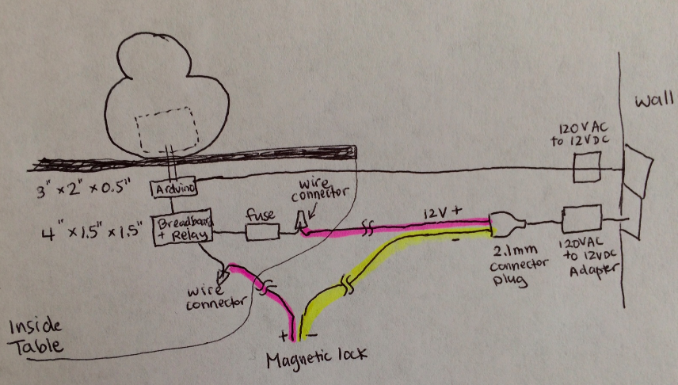

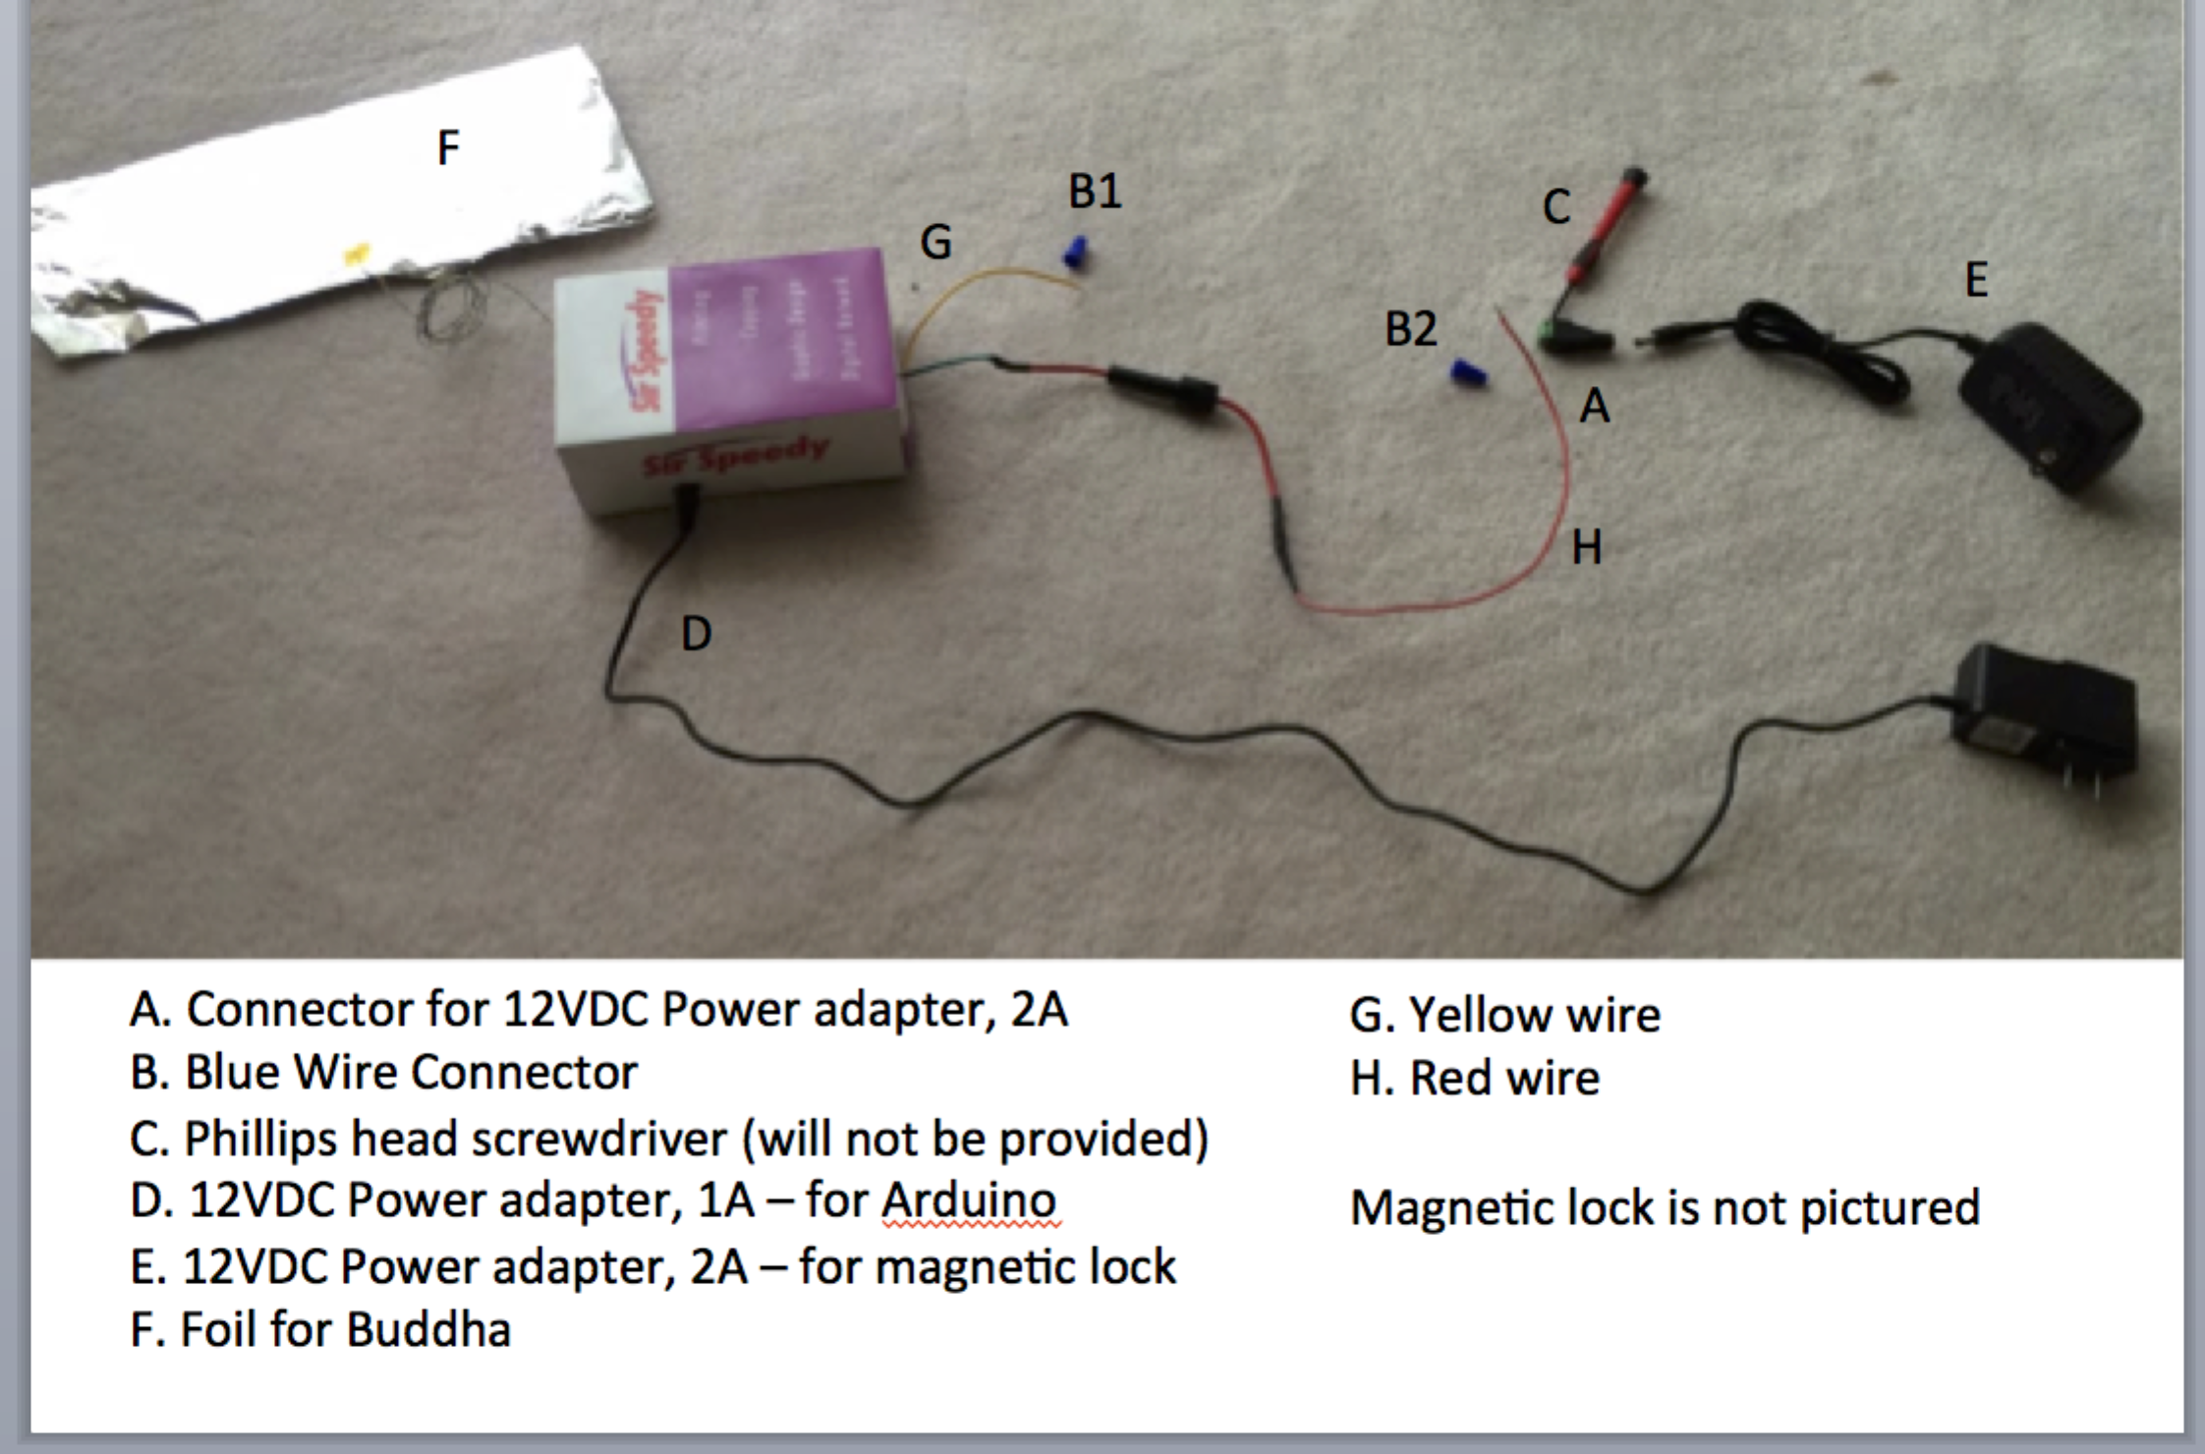

1. Connect power into the Arduino (D). Don’t plug into the outlet yet.
2. Connect wires to your 12VDC magnetic lock
   1. Use the blue wire connector (B1) and connect another wire to the yellow wire (G).
      1. Instructions on how to connect a wire: <http://www.familyhandyman.com/electrical/wiring/how-to-make-safe-wire-connections/view-all>
      2. This new wire should be long enough to reach the magnetic lock.
   2. Screw this new wire into the positive terminal of the magnetic lock
   3. Take a new wire and connect it from the negative terminal of the magnetic lock to the negative terminal (-) of the connector (A). Use a Phillips screwdriver (C)
3. Screw the red wire (H) into the positive terminal (+) of the connector (A). Use a Phillips screwdriver (C).
   1. Optional: If you need to use a longer wire, use the blue wire connector (B2) and connect another wire to the red wire (H). See instructions above on how to connect a wire
4. Connect the connector (A) into the 12VDC magnetic lock power adapter (E). Don’t plug into the outlet yet
5. Attach the foil (F) to the underside of the Buddha belly. Make sure the blue & yellow wire is securely taped to the foil using the supplied Kapton tape. Or you can choose to solder the blue & yellow wire to the foil.
6. Check all connections are secure
7. Plug the Magnetic power adapter (E) into an outlet
8. Plug the Arduino power adapter (D) into an outlet

**Software code**

1. Once you plug in the Arduino power adapter (D), there is a 10sec initialization period. The device is getting an average baseline reading at the blue & yellow wire/foil/Buddha belly. Do not touch the blue & yellow wire/foil/Buddha belly during this initialization period.
   1. The magnetic lock should be locked. 12V should be going through the relay
2. Touch the blue & yellow wire/foil/Buddha belly for 10 seconds or longer. The magnetic lock will be unlocked.
3. Touch the blue & yellow wire/foil/Buddha belly for <10seconds and the magnetic lock will lock

**Inside the box**

Dimensions: 6 inches x 4 inches x 2 inches

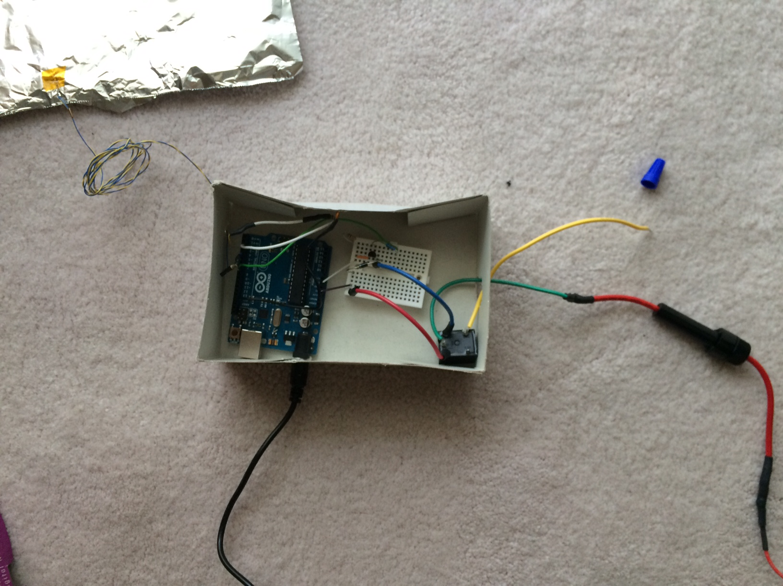

**Costs**

|  |  |  |  |
| --- | --- | --- | --- |
|  | **Unit cost** | **Qty** | **Total** |
| **Mechanical Components** |  |  |  |
| Arduino Uno | 25.81 | 1 | 25.81 |
| white breadboard | 1.5 | 1 | 1.5 |
| USB 2.0 A-B cable | 4.67 | 1 | 4.67 |
| 12V DC Power Adapter 2.1mm 1A | 5.4 | 1 | 5.4 |
| 12VDC Power Adapter 2.1mm 2A + connector | 6 | 1 | 6 |
| Blue wire connectors | 0.5 | 2 | 1 |
| Velcro | 0 | 1 | 0 |
| Kapton Tape | 0 | 1 | 0 |
| Fuse holder | 3.4 | 1 | 3.4 |
|  |  |  |  |
| **Electrical Components** |  |  |  |
| Fuse | 1 | 1 | 1 |
| 100p ceramic capacitor | 0.1 | 1 | 0.1 |
| 1k resistor | 0.1 | 1 | 0.1 |
| 1M resistor | 0.1 | 1 | 0.1 |
| 2N7000 N Channel MOSFET | 0.4 | 1 | 0.4 |
| Diode | 0.5 | 1 | 0.5 |
| JS1-B-5V-F Relay | 1.86 | 1 | 1.86 |
|  |  |  |  |
| Time (hr). Took 8 hrs. 1hr to prepare, 4hrs to implement, 3hrs to clean up and document. I quoted you for 5hrs so will only charge that. | 50 | 5 | 250 |
|  |  |  |  |
| **Shipping** |  |  |  |
| Fedex 5 day shipping. Tracking number: 781173195839 |  |  | 16.35 |
|  |  |  |  |
|  |  |  |  |
|  |  | **TOTAL** | **318.19** |